Lecture 13
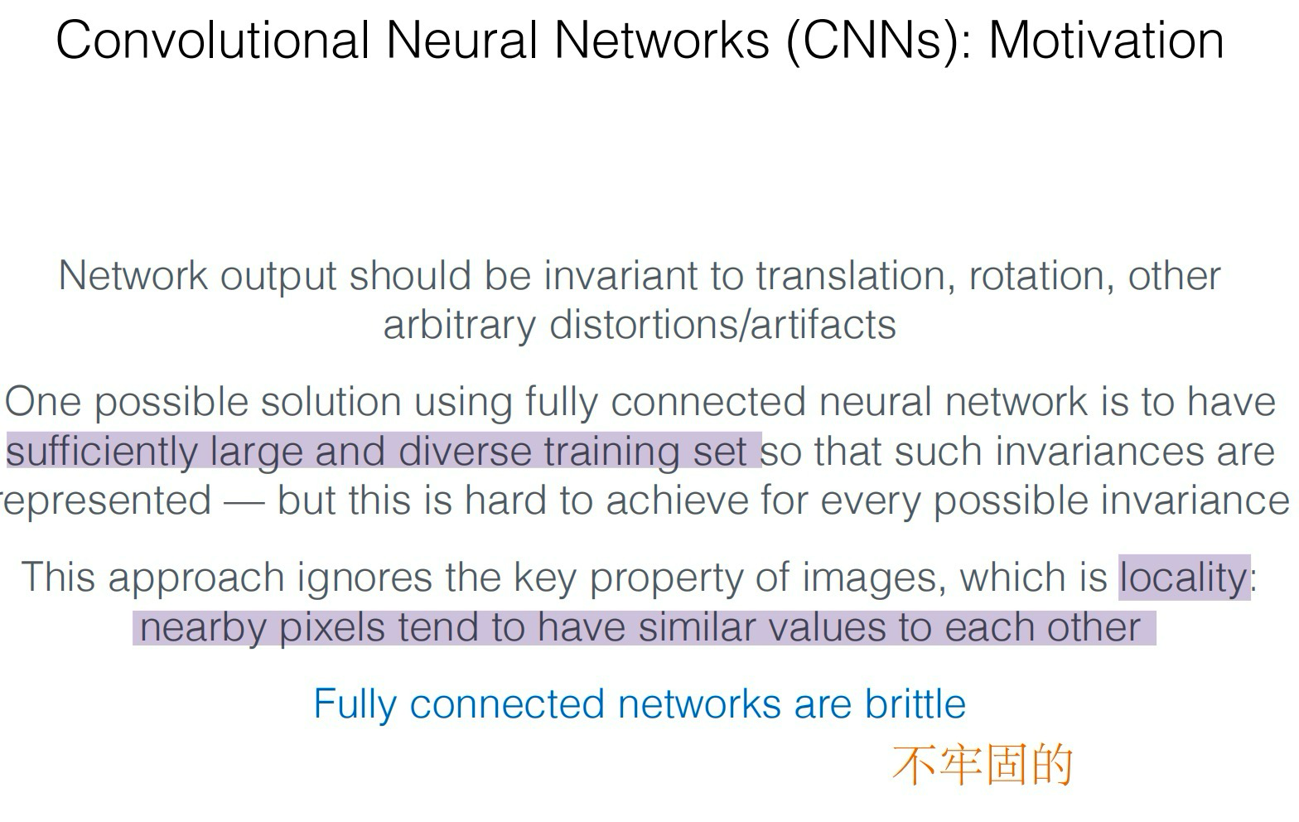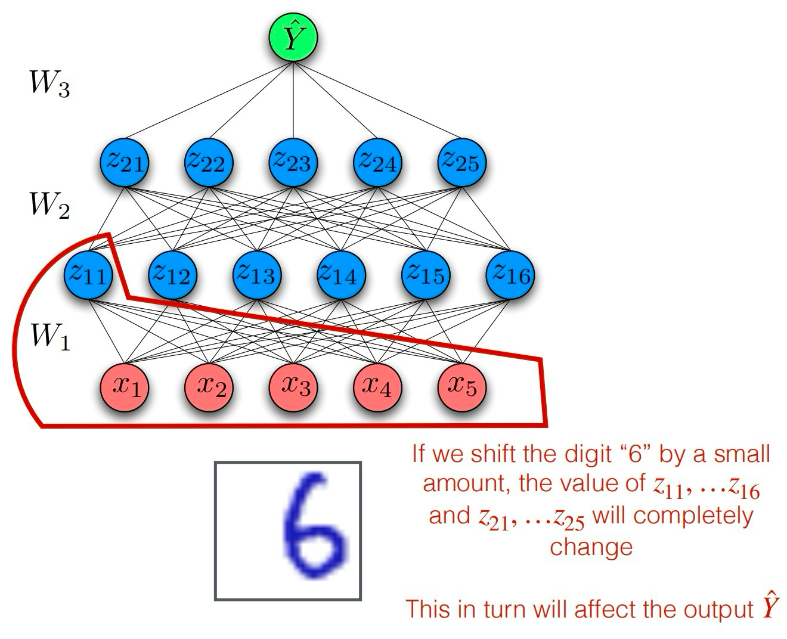
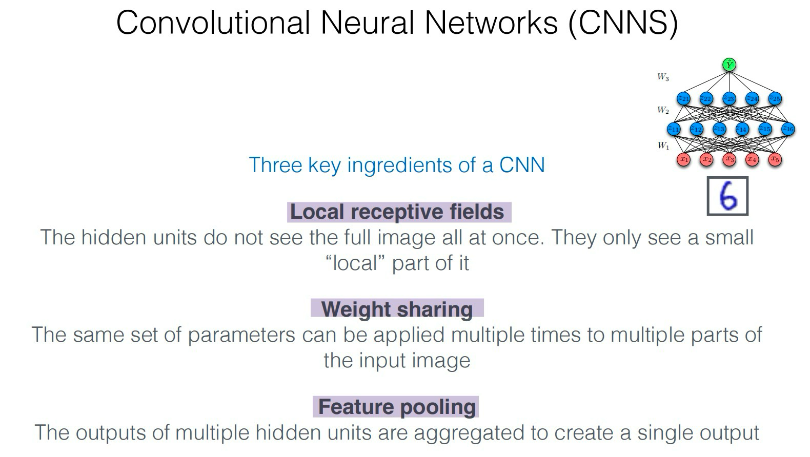
1.Why it helps: Natural images have local structure (edges, corners). Focusing locally reduces parameters and matches reality.
2.connsequence:
- Translation equivariance: shift the input → the feature map shifts the same way (the detector fires wherever the pattern appears).
- Huge parameter savings → less overfitting, faster training, works well even with limited data.
3.
Translation invariance (approx.): if a stroke moves by 1–2 pixels, the pooled signal barely changes.
Downsampling ⇒ fewer activations ⇒ lower compute and memory.

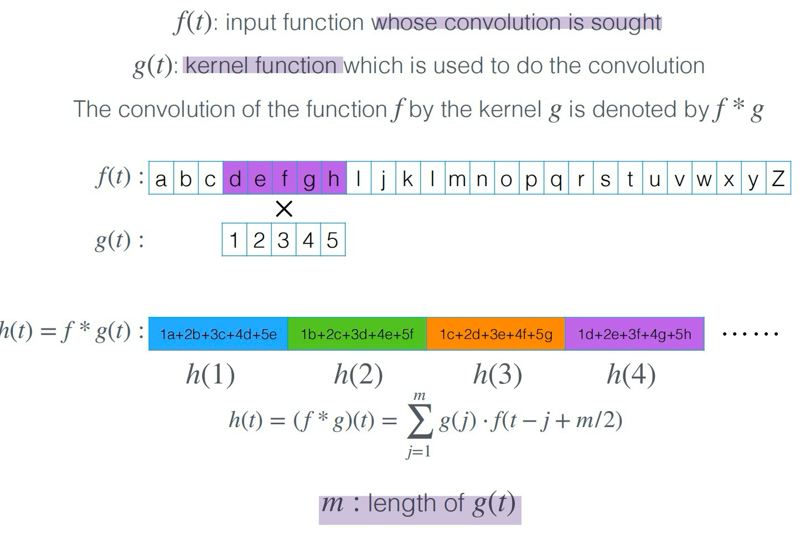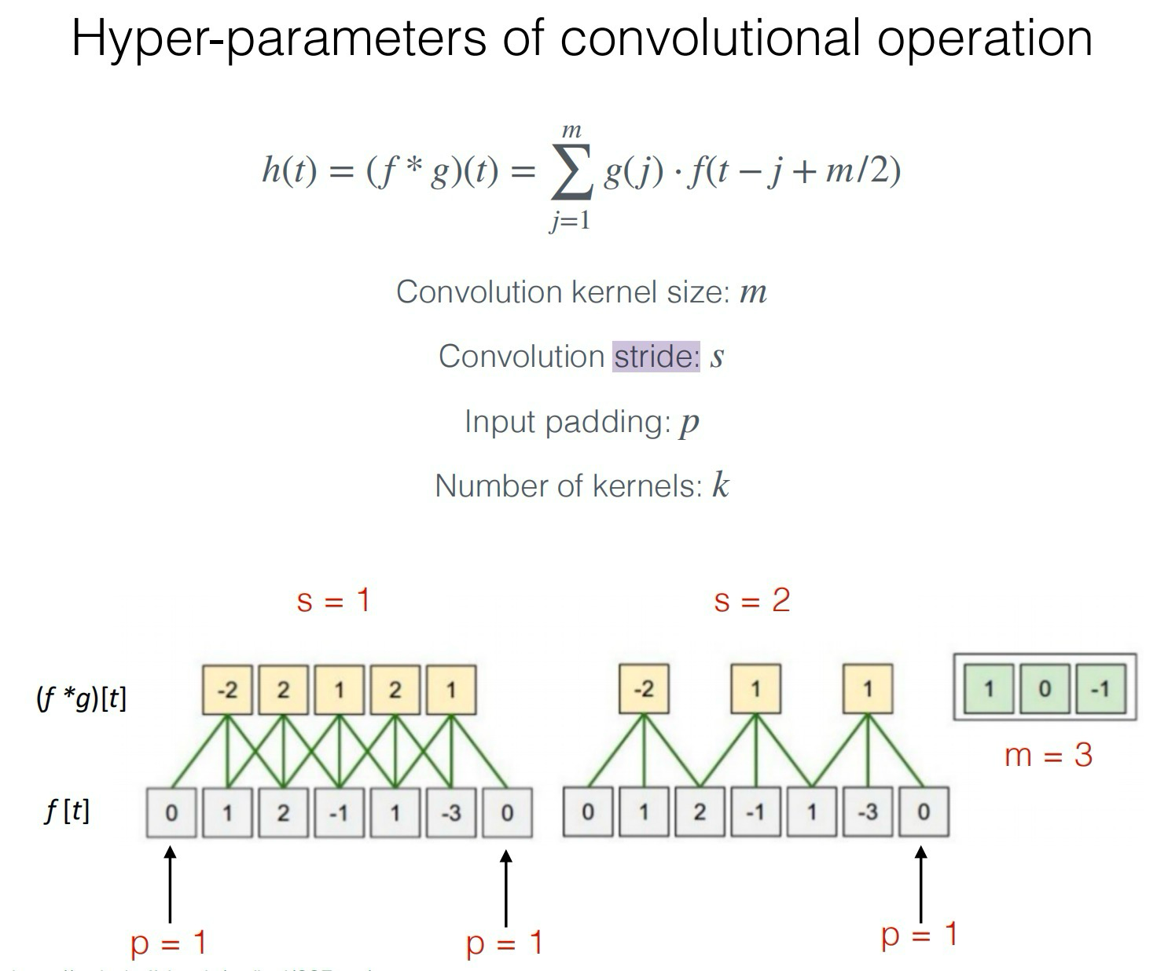

Padding is how we add extra pixels around the border of an input before applying a convolution
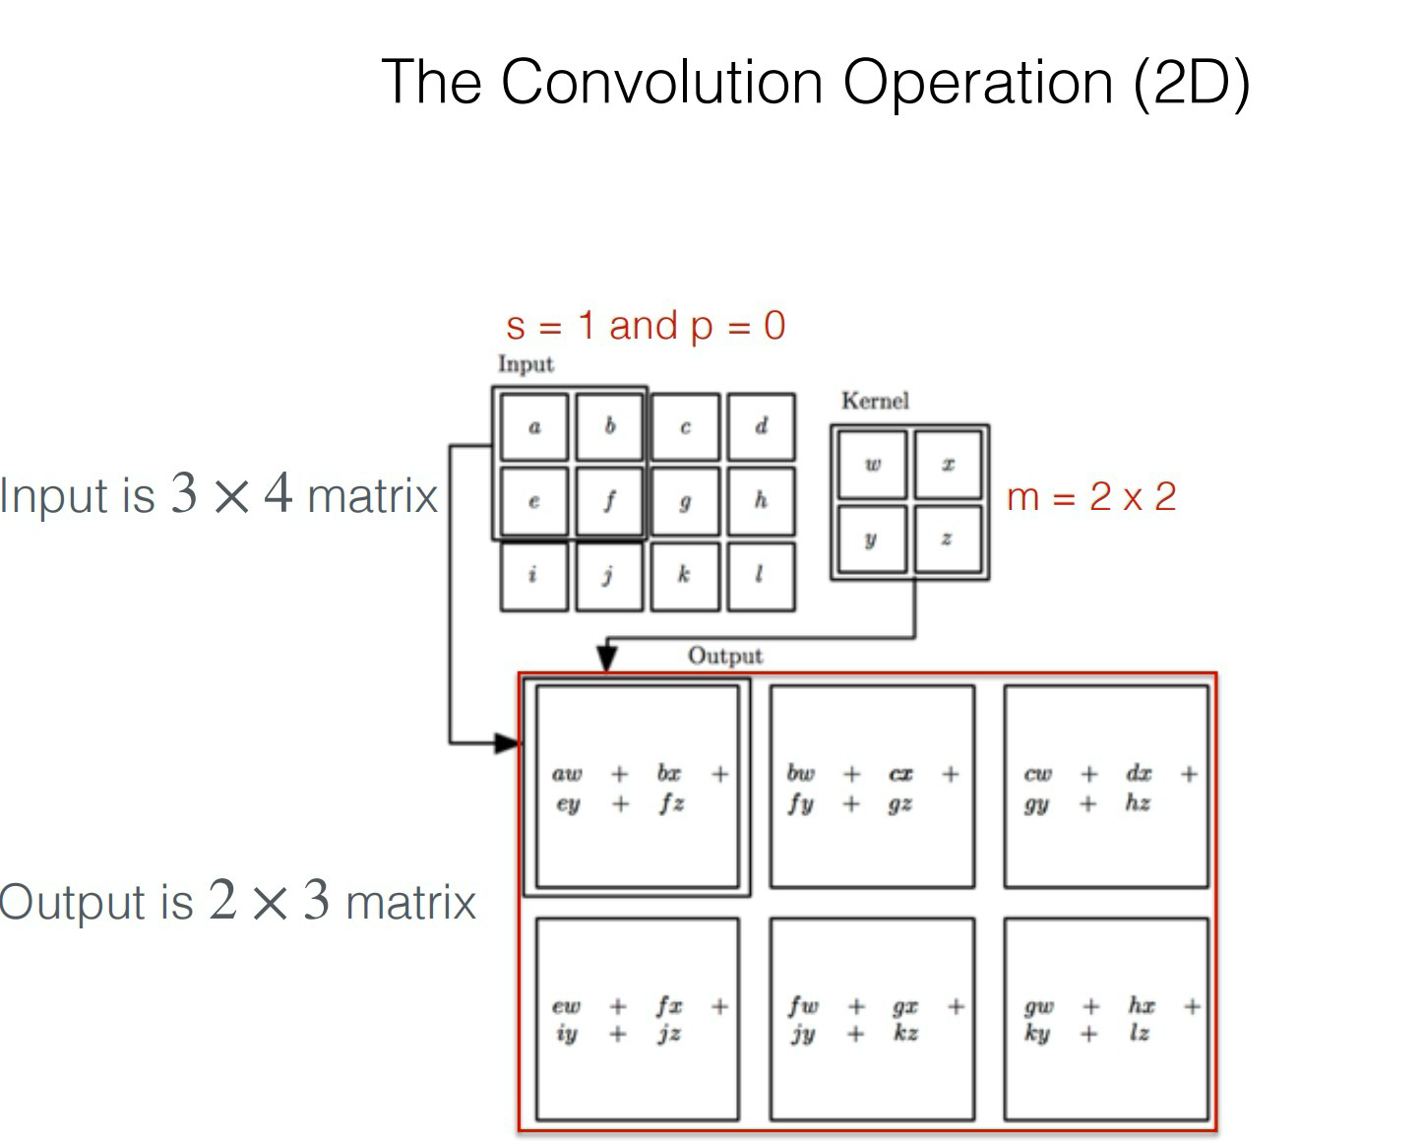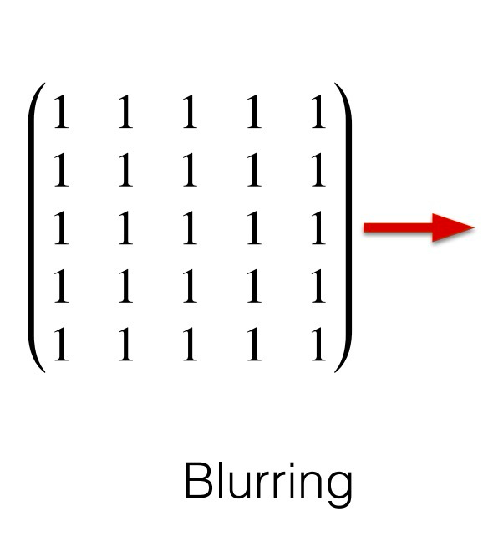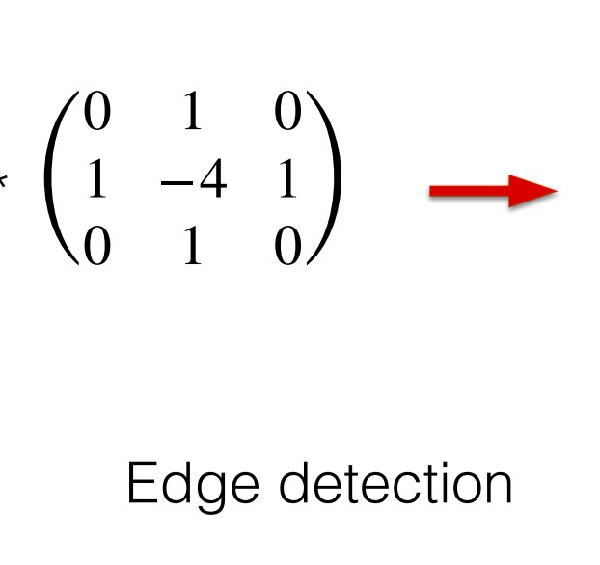

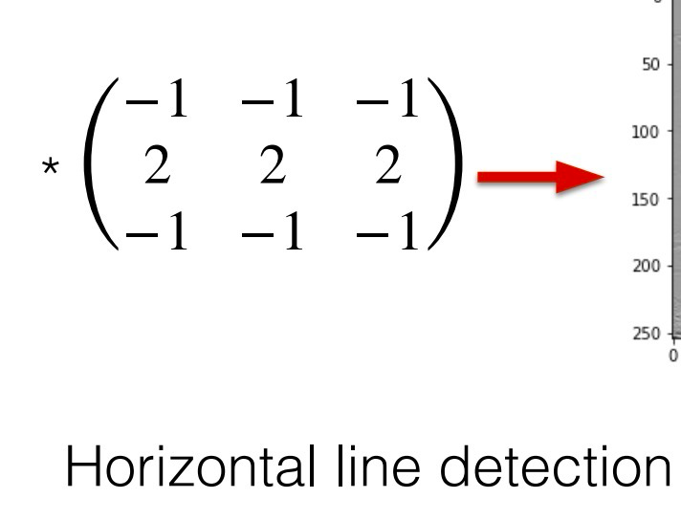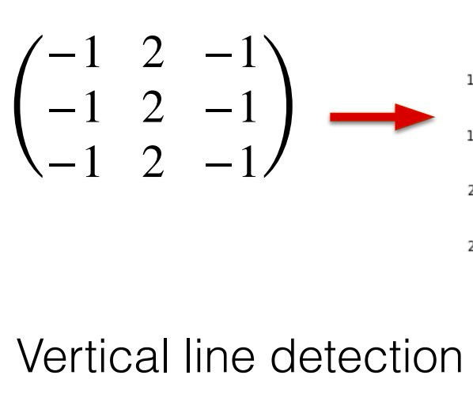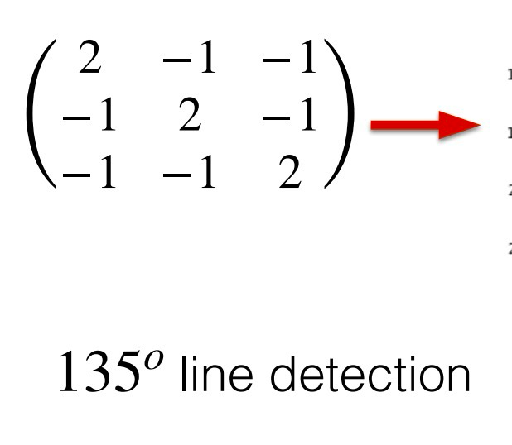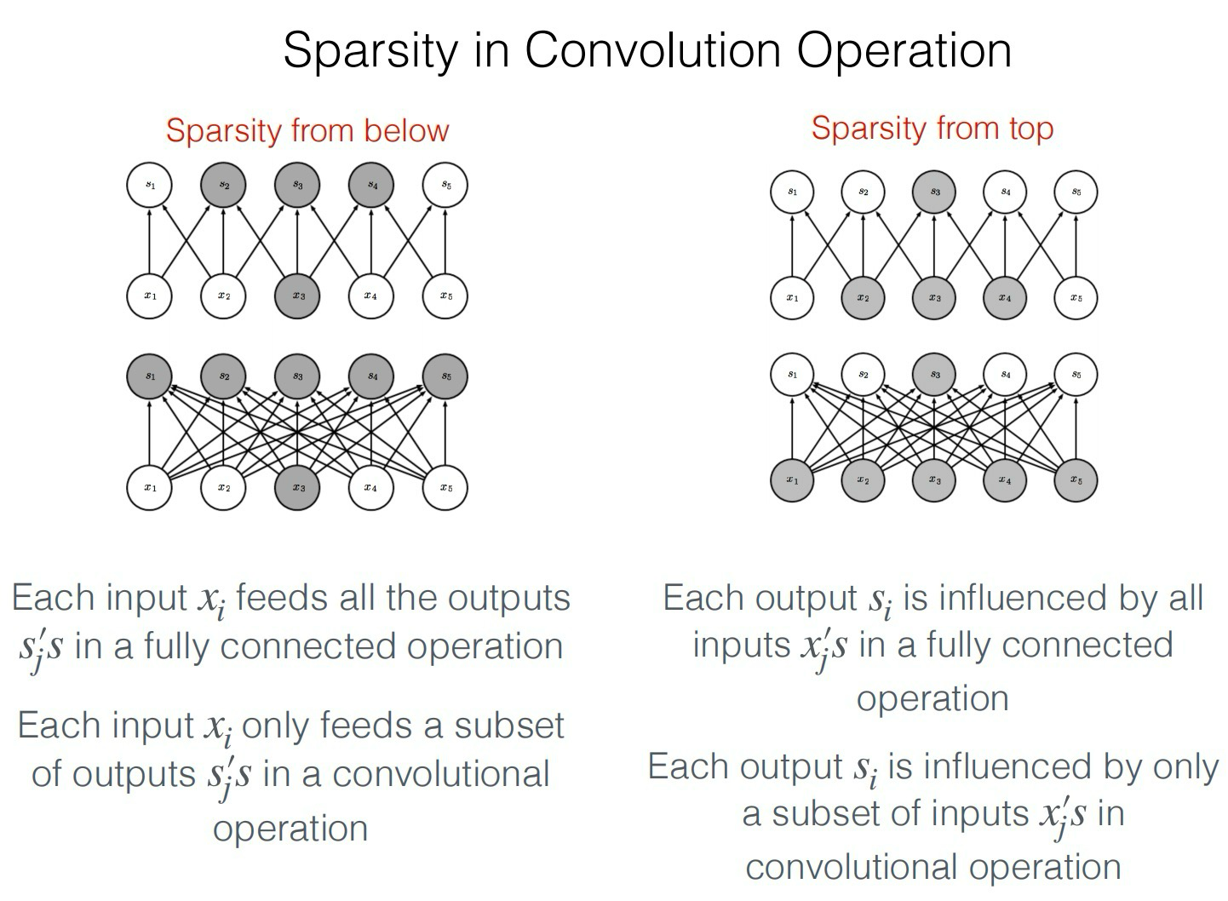
Connections exist only between nearby inputs and outputs (within a kernel window). All other potential connections are absent (zero). That’s why a conv layer’s weight matrix is mostly zeros if you wrote it out explicitly.
